Sample Letter of Medical Necessity*
(*This template is intended only as an example. It should be customized with patient-specific details and any other information deemed necessary, then printed on your letterhead prior to submission to the payer.)
[Insert physician letterhead]

[Medical Director] RE: Patient Name
[Insurance Company] Policy Number
[Address] Claim Number
[City, State, ZIP]
Dear [Insert name of Medical Director]:
Please accept this Letter of Medical Necessity for the patient named above. Below is a summary of the patient’s history [You may want to include]:
• Patient’s condition and history
• Previous therapies the patient has undergone for the symptoms associated with moderate to severe plaque psoriasis
• Patient’s response to these therapies
• Brief description of the patient’s recent symptoms and conditions

☐ Rationale for Treatment
I believe that treatment of [insert patient name] with SILIQ is appropriate and medically necessary. Please reference the clinical peer-reviewed literature and package insert that support SILIQ as an appropriate therapy. In addition, my primary rationale for treatment with SILIQ is that it works differently that other products in the IL-17 class.
☐ Mechanism of Action
SILIQ is the only commercially available drug that is an IL-17RA blocker. SILIQ is a human monoclonal IgG2 antibody and the only treatment option that selectively binds to human IL-17RA subtype with high affinity and inhibits its interactions with cytokines IL-17A, IL-17F, IL-17C. IL-17A/F heterodimer, and IL-25 to inhibit the release of pro-inflammatory cytokines and chemokines^{1,2}.
- National Psoriasis Foundation website. Biologics. Accessed June 21, 2022. https://www.psoriasis.org/biologics/
- SILIQ [prescribing information]. Bridgewater, NJ: Bausch Health US, LLC.
☐ SILIQ Rescue Data
SILIQ is the only biologic that has rescue data in all three classes.
In a post-hoc analysis of two phase 3 trials from the subgroup of patients who reported failing on TNF-alpha inhibitor therapy prior to entering the study (n=150) at week 12, 63% were able to obtain a PASI 90 response, and 32% became totally clear with SILIQ³. Treatment failure was defined as either a primary (lack of efficacy) or secondary (loss of efficacy) failure or the development of an intolerance to the biologic agent.
Data from an open-label study of 39 patients at three sites who had previously failed treatment with ixekizumab (N=19; 49%) or secukinumab (N=16; 41%). Failure was defined as not achieving 75% clearance after 3 months of treatment or a 50% loss of original improvement. Among those patients, at week 16, 44% were able to obtain 90% clearance with SILIQ, and 28% were able to obtain total clearance⁴.
In a post-hoc analysis of pooled data from two Phase 3 studies (AMAGINE-2 and AMAGINE-3) from the subgroup of patients who failed on ustekinumab and then switched to SILIQ (N=124), 58% reached PASI 90 by week 52, while 36% reached PASI 100 by week 52. Failure was defined as patients with sPGA score of 3 or greater or persistent sPGA score of 2 over a >4-week period, after at least 16 weeks of treatment with ustekinumab⁵.
- Papp KA et al. Br J Dermatol. 2018;179(2):320-328.
- Kimmel G et al. J Am Acad. Dermatol. 2019;81(3):857-859.
- Langley RG et al. Br J Dermatol. 2019;180:255-256.

☐ SILIQ Recapture Data
AMAGINE-1 was a phase 3 study in which patients initially treated with brodalumab and then placebo were eligible to return to brodalumab if disease returned (sPGA>3) any time after Week 16. The average time for the disease to return after stopping SILIQ was 75 days, with the median time being 56 days. Nearly all patients were able to recapture their previous level of efficacy within 24 weeks of restarting SILIQ^{6,7}.
- Data on file (AMAGINE-1).
- Papp KA et al. Br J Dermatol. 2016;175:273-286.
☐ SILIQ Long-Term Data
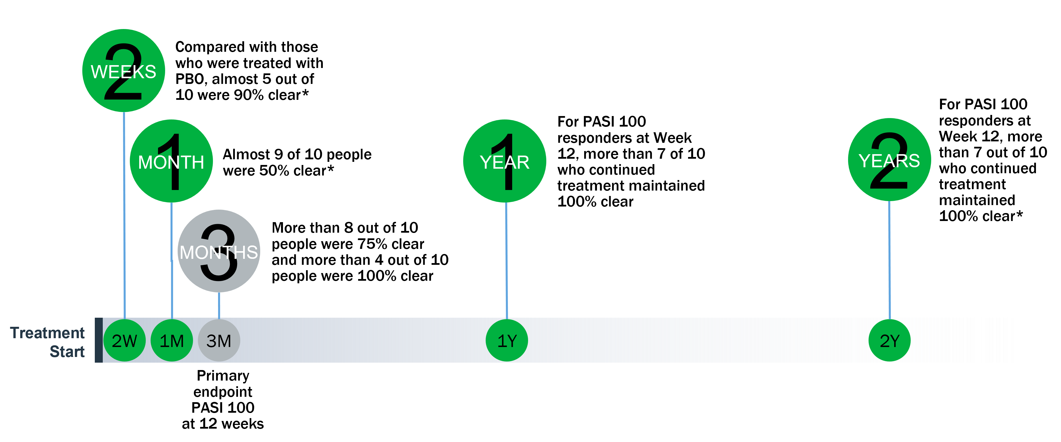
*Results were not key study endpoints and were considered observational only, which limits their applicability.

Additional important safety information about SILIQ and link to the full Prescribing Information is provided below. I look forward to receiving your timely response and approval of this claim.

Before prescribing SILIQ, please see Boxed Warning about suicidal ideation and behavior below.
WARNING: SUICIDAL IDEATION AND BEHAVIOR
Suicidal ideation and behavior, including completed suicides, have occurred in patients treated
with SILIQ. Prior to prescribing SILIQ, weigh the potential risks and benefits in patients with a history
of depression and/or suicidal ideation or behavior. Patients with new or worsening suicidal ideation
and behavior should be referred to a mental health professional, as appropriate. Advise patients and caregivers to seek medical attention for manifestations of suicidal ideation or behavior, new onset or worsening depression, anxiety, or other mood changes [see Warnings and Precautions in the full Prescribing Information].
Because of the observed suicidal behavior in subjects treated with SILIQ, SILIQ is available only
through a restricted program under a Risk Evaluation and Mitigation Strategy (REMS) called the
SILIQ REMS Program [see Warnings and Precautions in the full Prescribing Information].
For full Prescribing Information, click here or call Medical Information at (877) 361-2719 to request
that it be faxed, emailed or mailed instead.
Sincerely,
[Insert Physician Name and Participating Provider Number]
Enclosures

